Go to your RosKassa account

[https://my.roskassa.net/shop-settings/](https://my.roskassa.net/shop-settings/%20)

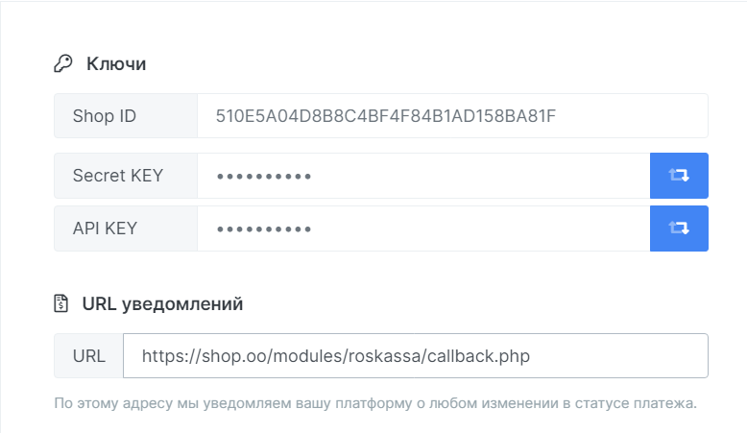

The CALLBACK link will look like this https: //shop.oo/modules/roskassa/callback.php - you need to change the domain name to yours.

Next, you need to make settings in the PrestaShop panel

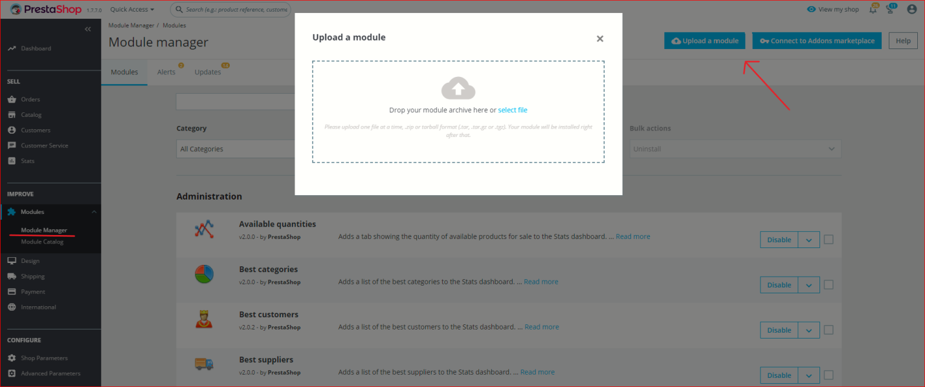

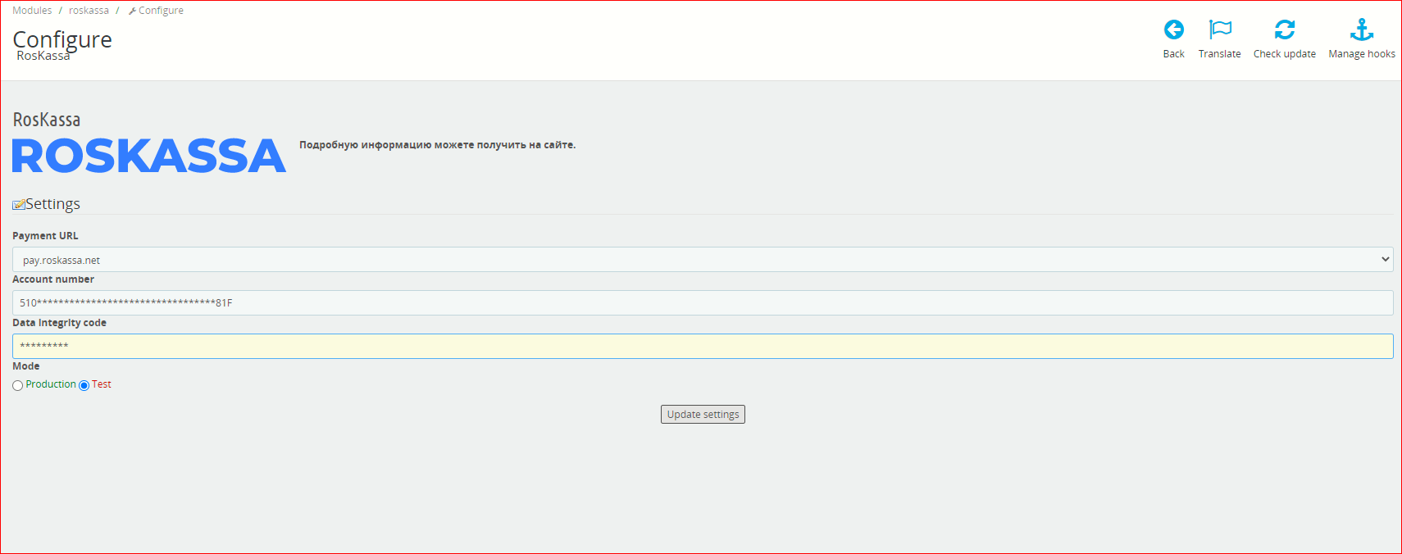

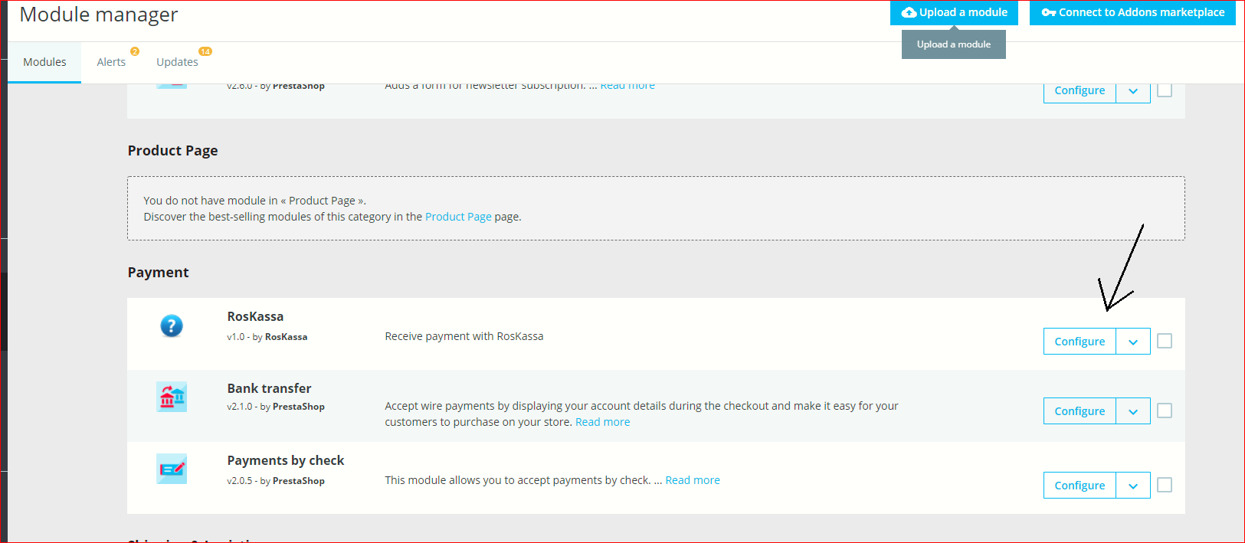

Three easy steps and you can accept payment.

For information

<https://roskassa.net/join.php?p=1000205>